Formal Methods in Software Engineering

Project Report

**By**

**Abdul Moiz**

Table of Contents

**1. Introduction** 3

**2. Language Syntax and Parser Assumptions** 4

**2.1 Input Program Syntax** 4

**2.2 Postcondition Assertion Format** 4

**2.3 Parser Assumptions** 4

**3. SSA Translation Logic** 6

**3.1 Conversion to SSA** 6

**3.2 SSA Optimizations** 6

**3.3 Control Flow Graph Visualization** 7

**4. Loop Unrolling** 8

**5. SMT Formulation Strategy** 9

**6. GUI Design** 10

**7. Sample Programs and Test Results** 18

**7.1 Verification Mode** 18

**7.2 Equivalence Mode** 19

**8. Limitations** 21

**9. Potential Improvements** 21

**10. Conclusion** 22

**1. Introduction**

This report documents the design and implementation of a graphical tool for analyzing the correctness and equivalence of programs using formal methods. The tool parses programs written in a custom mini-language, converts them to Static Single Assignment (SSA) form, generates SMT constraints, and uses the Z3 solver to verify correctness or check program equivalence. The tool features a user-friendly GUI to display intermediate steps (AST, SSA, SMT constraints) and results, including counterexamples and examples where properties hold. The tool supports loop unrolling, SSA optimizations, and control flow graph visualization.

The tool fulfills the following objectives:

* Parse simple programs in a custom mini-language.
* Convert programs to SSA form with optimizations (constant propagation, dead code elimination, common subexpression elimination).
* Generate SMT constraints for verification and equivalence checking.
* Use Z3 to verify assertions and check equivalence, displaying results and counterexamples.
* Provide a GUI to visualize all steps, including AST, SSA, optimized SSA, SMT code, and control flow graphs.
* Handle loop unrolling with user-specified depth.
* Support verification and equivalence modes with appropriate example and counterexample generation.

**2. Language Syntax and Parser Assumptions**

**2.1 Input Program Syntax**

The tool accepts programs written in a simple imperative language with the following syntax:

* **Variables and Assignments**: Variables are assigned using := (e.g., x := 5).
* **Control Structures**:
  + if (condition) { ... } else { ... }
  + while (condition) { ... }
  + for (i := start; i < end; i := i + 1) { ... }
* **Arrays**: Arrays are supported with the syntax arr[i] for access and arr[i] := value for assignment.
* **Arithmetic and Logical Expressions**:
  + Arithmetic: +, -, *, /, %
  + Comparisons: ==, !=, <, <=, >, >=
  + Logical: &&, ||, !
* **Comments**: Lines starting with // are ignored.

**2.2 Postcondition Assertion Format**

Assertions are written as assert (condition), where condition is a boolean expression involving variables, arrays, and operators. Examples include:

* assert (x > 0)
* assert (arr[0] == 5)

**2.3 Parser Assumptions**

The parser (parser.js) makes the following assumptions:

* **Whitespace**: Leading/trailing whitespace is trimmed, and multiple spaces are treated as a single space.
* **Variable Names**: Must start with a letter and can contain letters, numbers, and underscores.
* **Array Syntax**: Assumes arr[i] for access and arr[i] := value for updates. The index i must be an integer or a variable resolving to an integer.
* **Balanced Braces**: Control structures must have matching { and }.
* **Assertions**: Must be in the form assert (condition) with the condition enclosed in parentheses.
* **No Nested Arrays**: Arrays are one-dimensional, and nested array operations (e.g., arr[i][j]) are not supported.

For arrays, the parser extracts array operations by matching patterns like (\w+)\[([^\]]+)\] for accesses and (\w+)\[([^\]]+)\]\s*:=\s*(.+) for assignments. It assumes array indices are integers or variables and does not handle dynamic array sizes explicitly.

**3. SSA Translation Logic**

**3.1 Conversion to SSA**

The SSA conversion is implemented in utils/ssa.js (convertToSSA function). The process involves:

1. **Parsing to AST**: The input program is parsed into an AST using parseProgram.
2. **Variable Versioning**: Each variable assignment creates a new version (e.g., x := 5 becomes x_1 = 5, x := x + 1becomes x_2 = (+ x_1 1)).
3. **Loop Unrolling**: Loops are unrolled up to the user-specified depth, with loop variables versioned for each iteration.
4. **Control Flow Handling**: if statements are translated to SMT ite (if-then-else) constructs for variables assigned in both branches.
5. **Assertions**: Assertions are preserved as assert statements in SSA form with updated variable versions.
6. **Array Handling**: Array assignments (arr[i] := v) become (store arr_k i v), and accesses (arr[i]) become (select arr_k i).

The output is an object containing:

* original: The input AST.
* transformed: The raw SSA code with all statements.
* optimized: The optimized SSA code after applying optimizations.

**3.2 SSA Optimizations**

The optimizeSSA function implements the following optimizations:

* **Constant Propagation**: Replaces variables with constant values where possible (e.g., x_1 = 5; y_1 = x_1 + 1becomes y_1 = 6).
* **Dead Code Elimination**: Removes assignments to variables that are never used (e.g., z_1 = 10 is removed if z_1is not referenced).
* **Common Subexpression Elimination**: Reuses identical expressions (e.g., y_1 = x_1 + 1; z_1 = x_1 + 1becomes y_1 = x_1 + 1; z_1 = y_1).

**3.3 Control Flow Graph Visualization**

The tool generates control flow graphs (CFGs) for both the original program and the SSA form using a graph visualization library (e.g., Cytoscape.js). The CFG is constructed by:

* Identifying basic blocks (sequences of statements without branches).
* Creating edges for control flow (e.g., from an if condition to then and else blocks).
* Displaying nodes as statements or conditions, with edges labeled for true/false branches.
* For SSA, nodes reflect versioned variables and unrolled loops.

The CFGs are displayed side-by-side in the GUI, with the original CFG showing the program structure and the SSA CFG showing unrolled loops and versioned variables.

**4. Loop Unrolling**

Loop unrolling is handled in convertToSSA:

* **User Input**: The GUI provides a numeric input field for specifying the unrolling depth (default: 3).
* **For Loops**: A for loop like for (i := 0; i < n; i := i + 1) is unrolled by:
  + Initializing the loop variable (i_1 = 0).
  + Generating SSA statements for each iteration up to the specified depth.
  + Updating the loop variable for each iteration (i_2 = (+ i_1 1), etc.).
  + Including loop body statements with updated variable versions.
* **While Loops**: A while loop is unrolled similarly, with the condition checked at each iteration (assert (condition)).
* **Display**: The unrolled SSA code is shown in the GUI, with comments indicating iteration numbers (e.g., // Unrolled iteration 1).

Example:

for (i := 0; i < 3; i := i + 1) {

x := x + 1;

}

With unroll depth 3, becomes:

i_1 = 0

assert (< i_1 3)

x_1 = (+ x_0 1)

i_2 = (+ i_1 1)

assert (< i_2 3)

x_2 = (+ x_1 1)

i_3 = (+ i_2 1)

assert (< i_3 3)

x_3 = (+ x_2 1)

**5. SMT Formulation Strategy**

The SMT generation is implemented in utils/smt.js (generateSMT function). The strategy is:

1. **Logic Selection**: Uses (set-logic QF_AUFLIA) to support integers, booleans, and arrays.
2. **Variable Declarations**: Extracts all variables from SSA code using extractVariables and declares them with appropriate types (Int, Bool, (Array Int Int)).
3. **Array Handling**: Declares arrays as (Array Int Int) when (store) or (select) operations are detected.
4. **Constraints**:
   * **Assignments**: Converted to (assert (= var expr)) (e.g., x_1 = 5 becomes (assert (= x_1 5))).
   * **Assertions**: Preserved as (assert condition) with SSA variable versions.
   * **Array Operations**: (store) and (select) are passed directly as SMT constraints.
5. **Verification Mode**:
   * Adds program constraints and assertions.
   * Includes a negated property (assert (not (and (>= out_k 0) (<= out_k 100)))), where out_k is the latest version of out.
   * An unsat result indicates the property and assertions hold.
6. **Equivalence Mode**:
   * Adds constraints for both programs.
   * Checks (assert (not (= out1_k out2_k))), where out1_k and out2_k are the output variables.
   * An unsat result indicates equivalence.
7. **Counterexamples**: If sat, the Z3 model provides counterexample values for variables.

The SMT formula is displayed in the GUI, with syntax highlighting for readability.

**6. GUI Design**

The GUI is implemented as a single-page web application using React, Tailwind CSS, and Cytoscape.js for CFG visualization. The layout includes:

* **Input Panel**:
  + Two text areas for program input (one for verification, two for equivalence).
  + Dropdown to select mode (Verification or Equivalence).
  + Numeric input for unrolling depth (default: 3).
  + Submit button to trigger analysis.
* **Output Panels**:
  + **AST**: Displays the parsed AST as a JSON tree.
  + **SSA**: Shows raw and optimized SSA code side-by-side in code blocks.
  + **SMT**: Displays the generated SMT formula with syntax highlighting.
  + **CFG**: Visualizes control flow graphs for original and SSA code using Cytoscape.js.
  + **Results**: Shows verification or equivalence results, including:
    - Status (verified, not_verified, equivalent, not_equivalent).
    - Counterexamples (if sat) or example inputs (if unsat).
    - Z3 output (sat, unsat, or error details).
* **Tabs**: Separate tabs for each output type (AST, SSA, SMT, CFG, Results) for clarity.

**Screenshots**

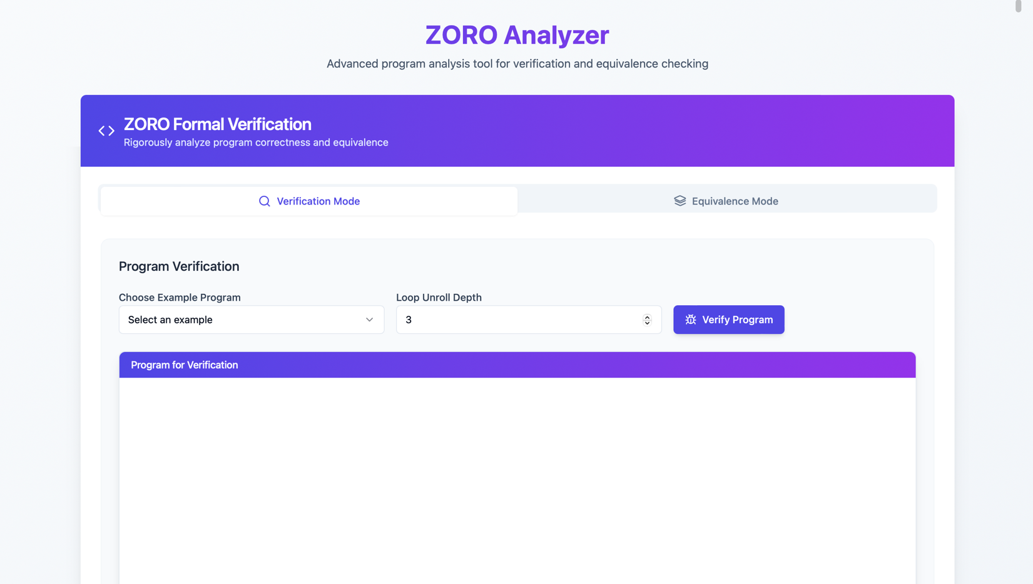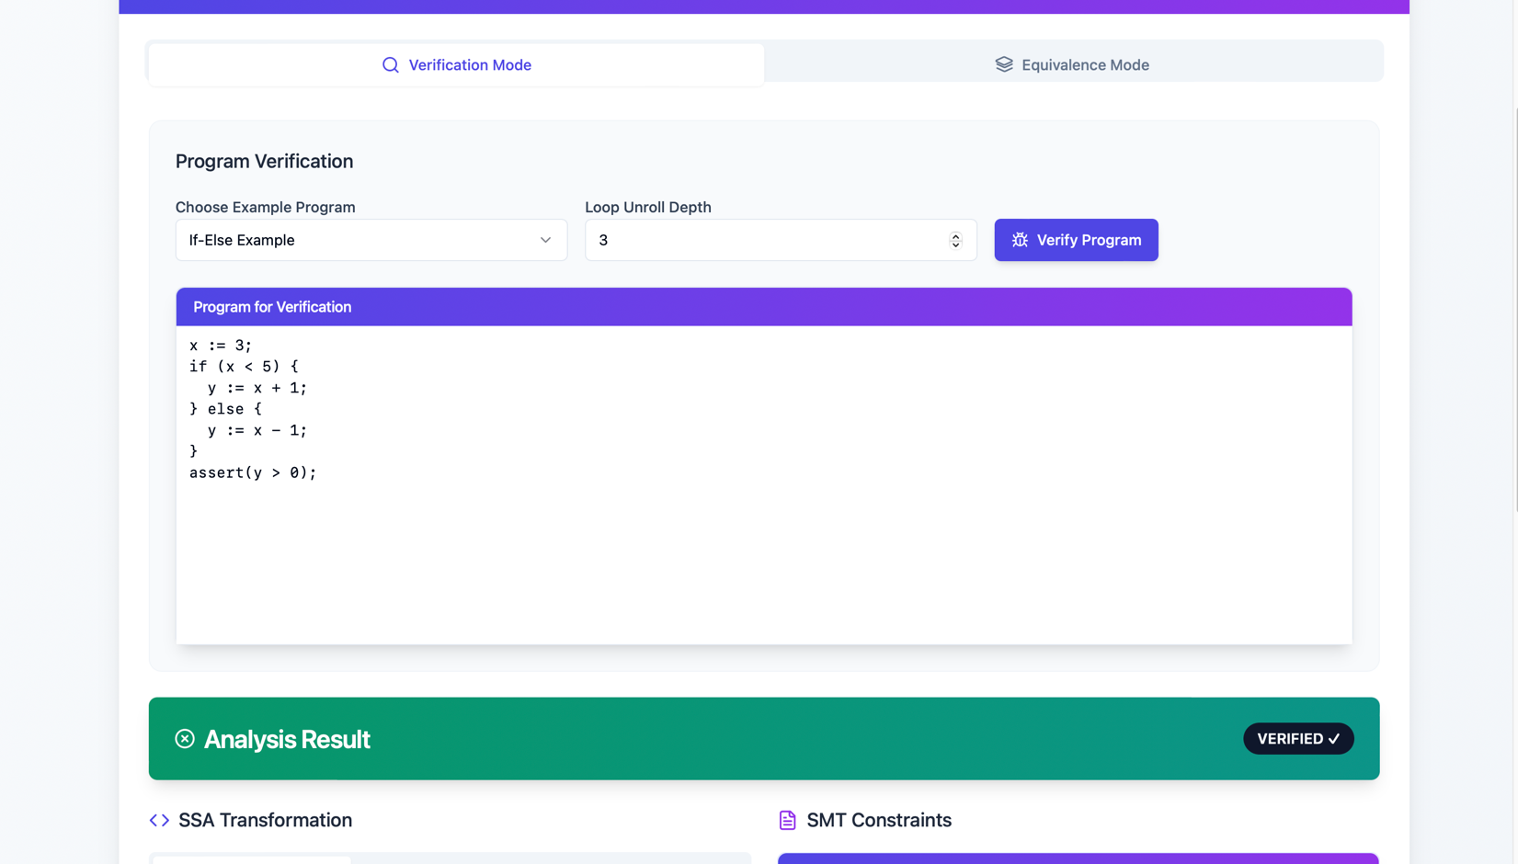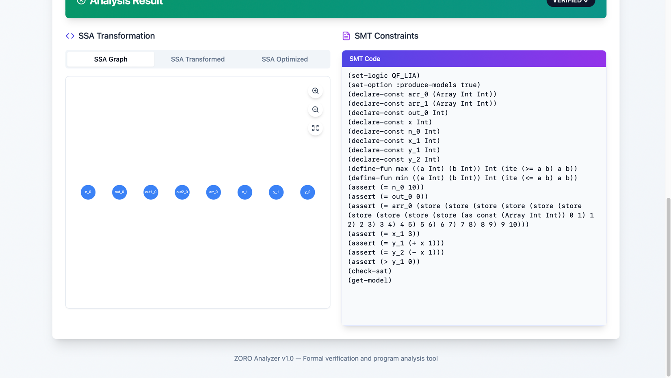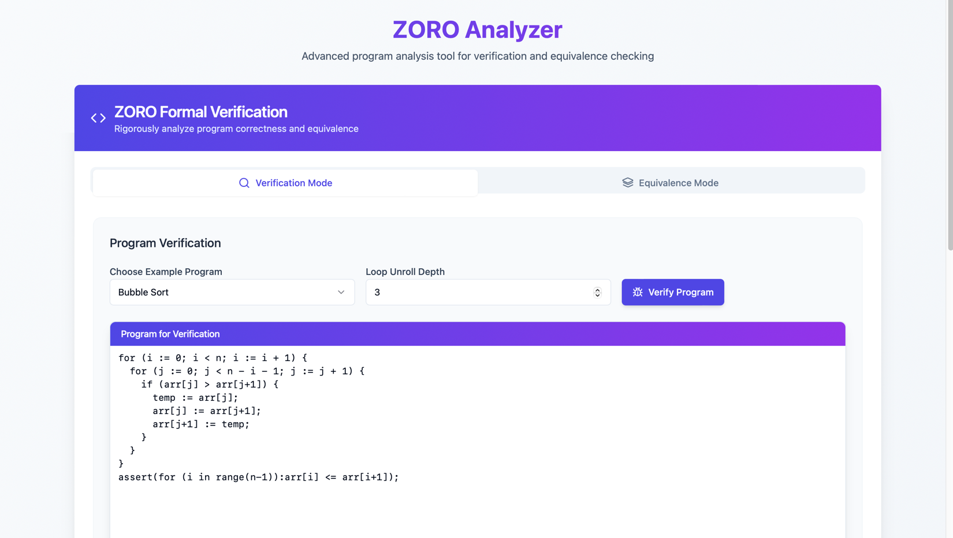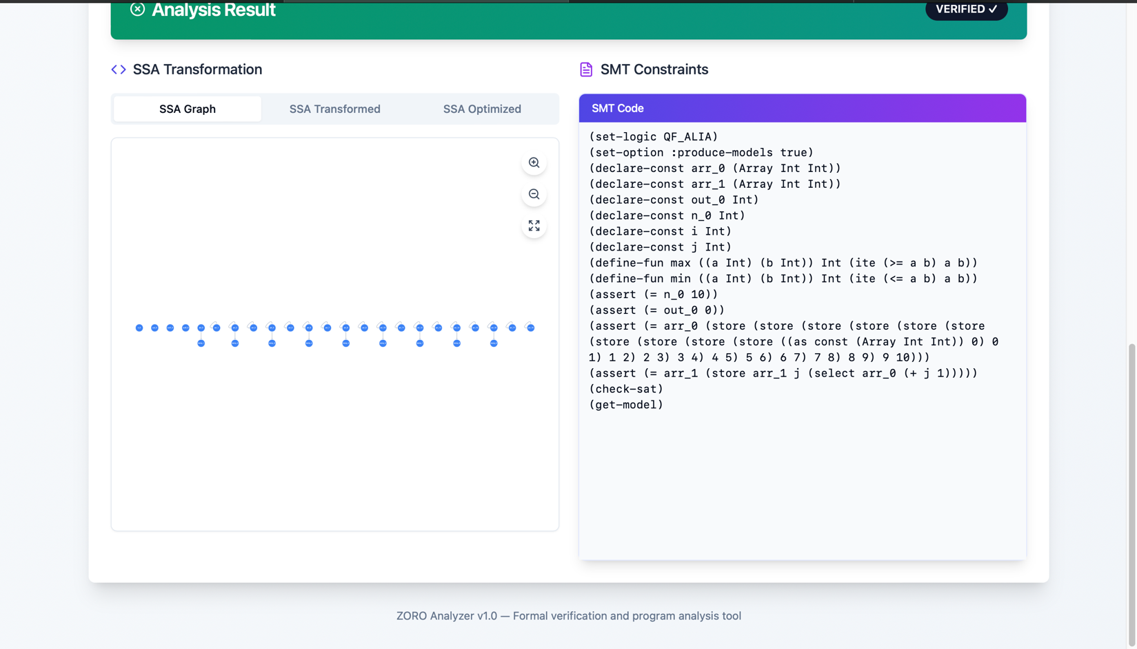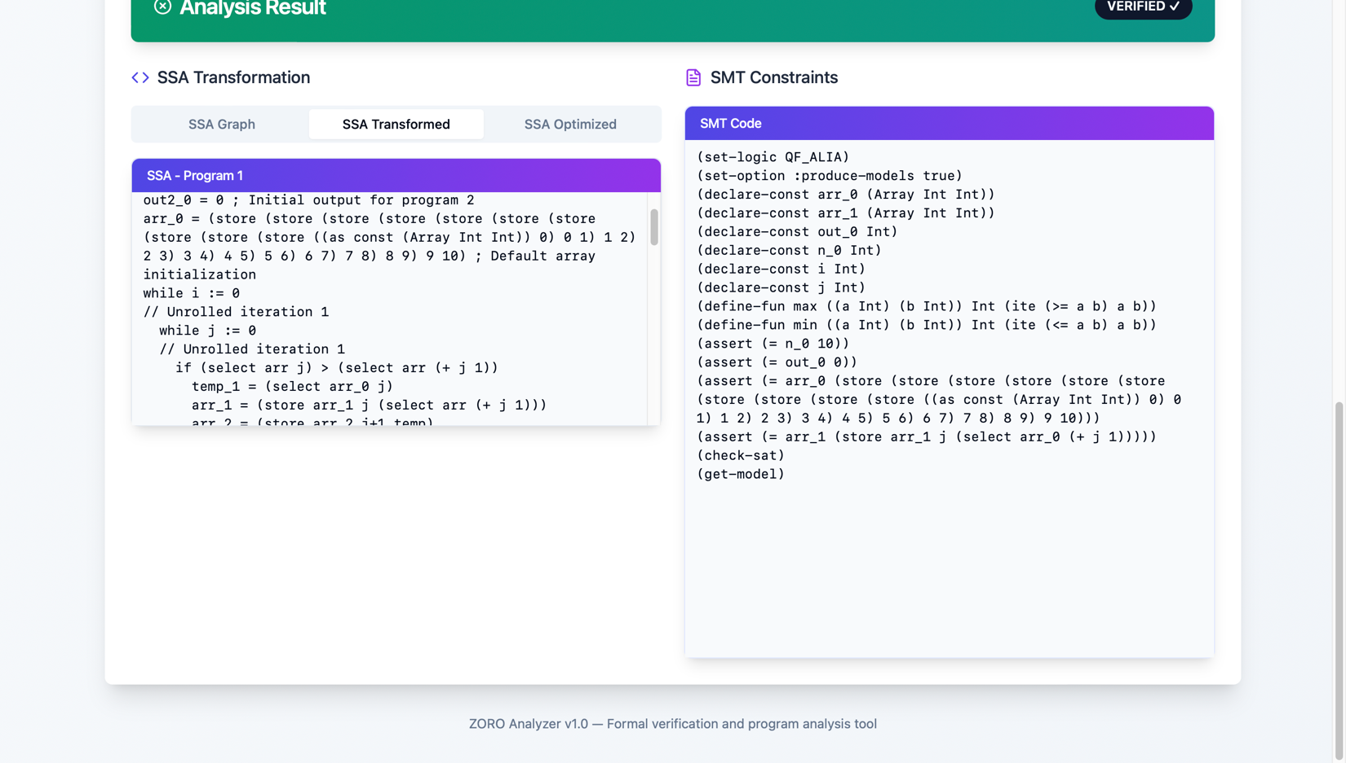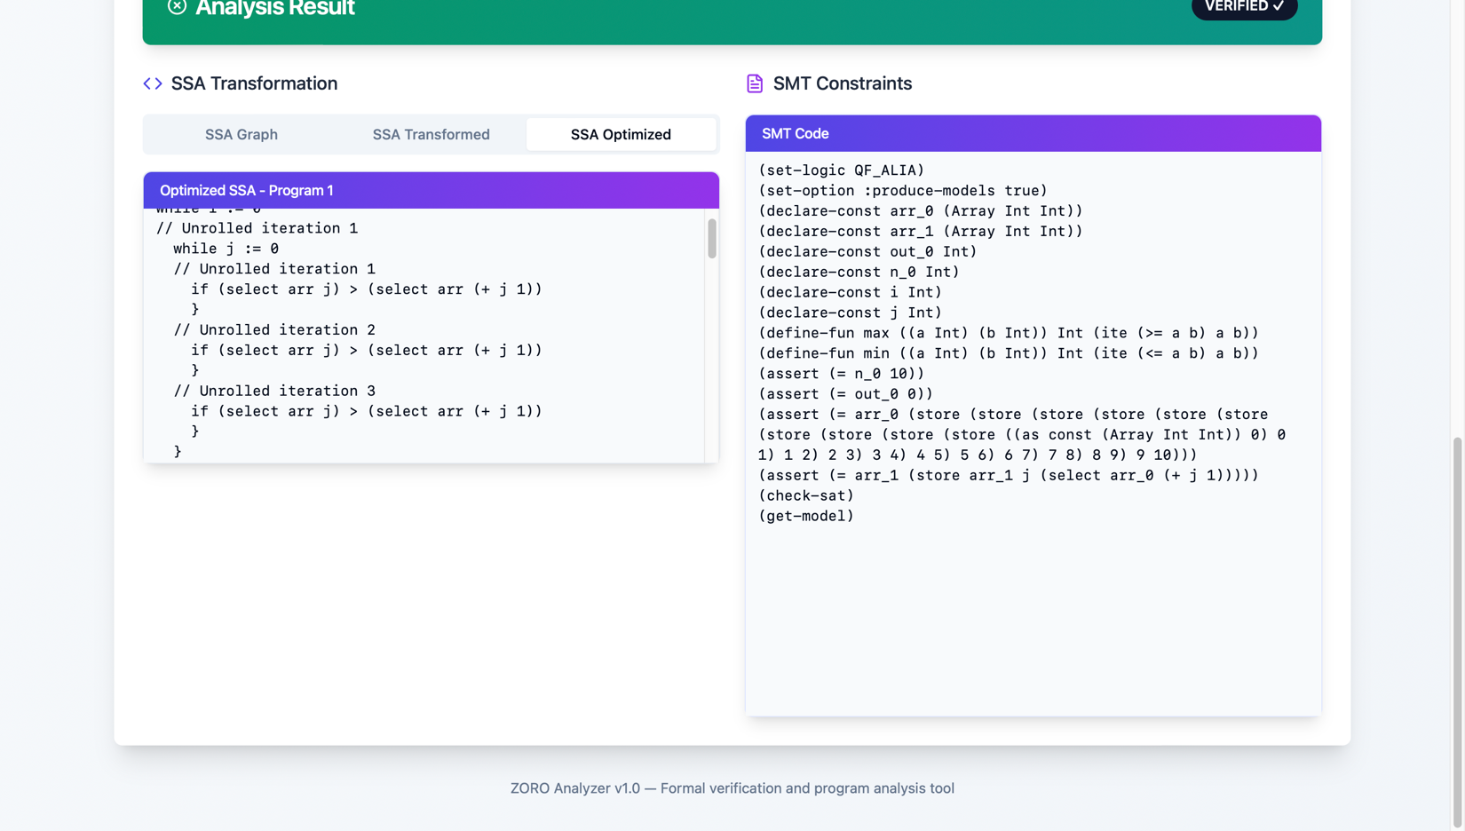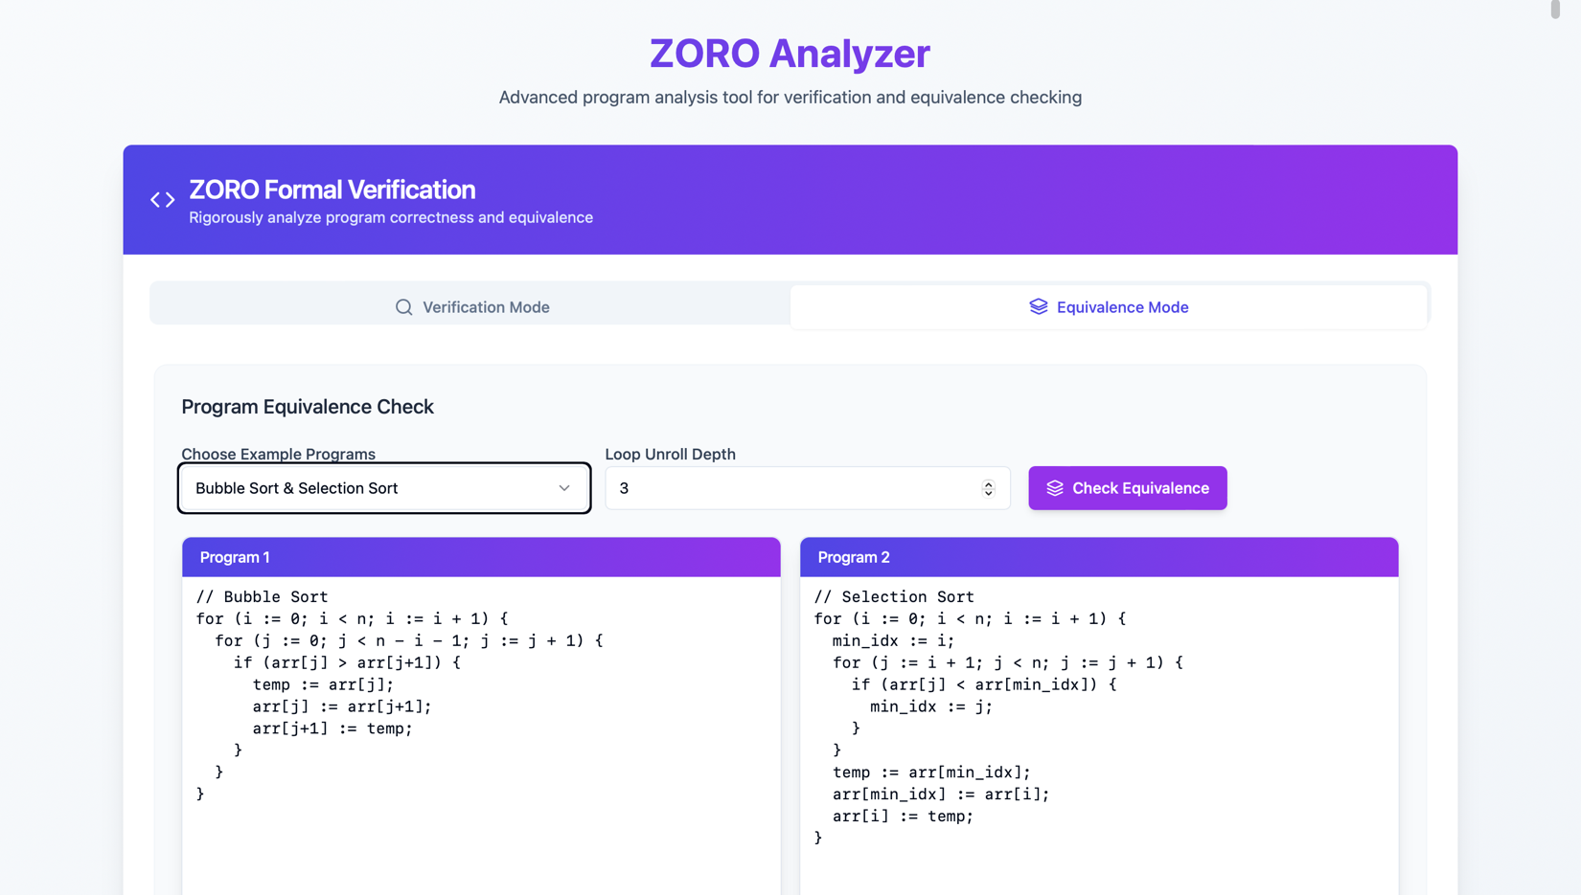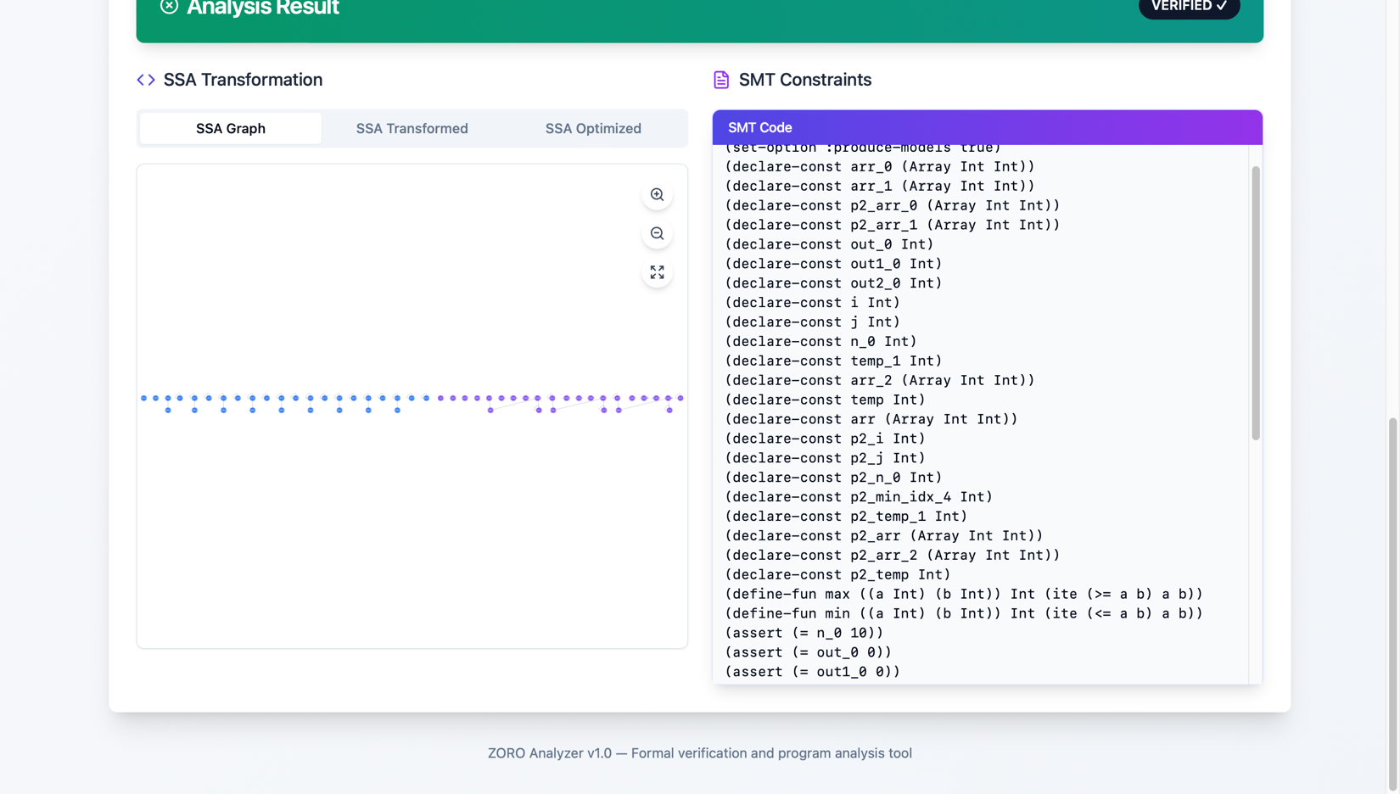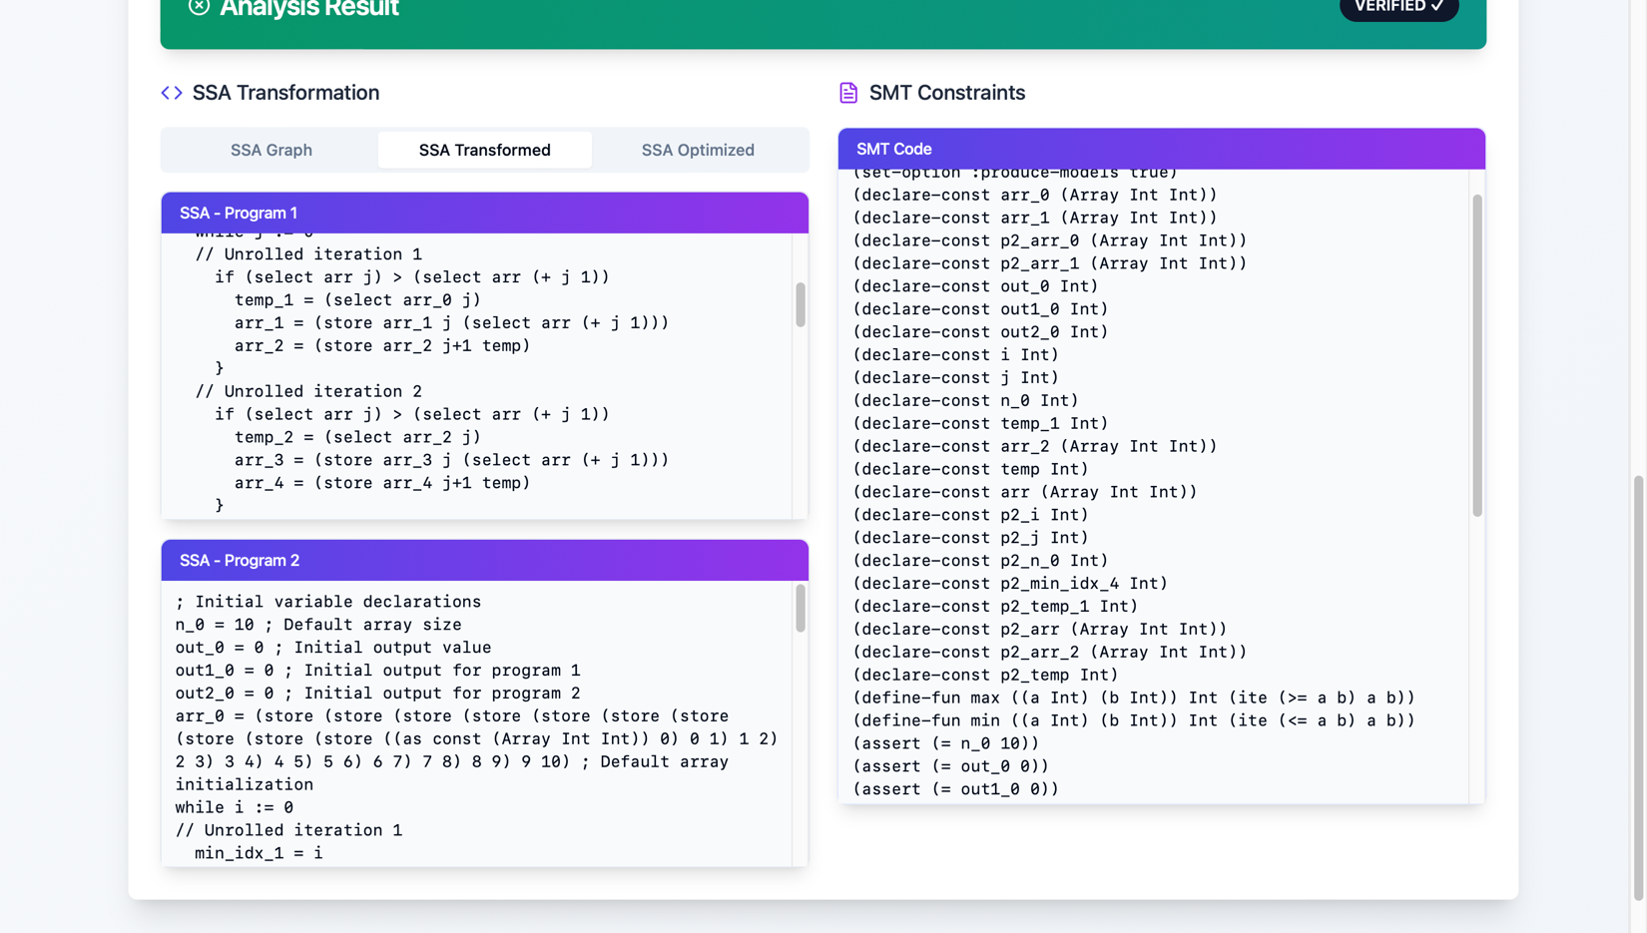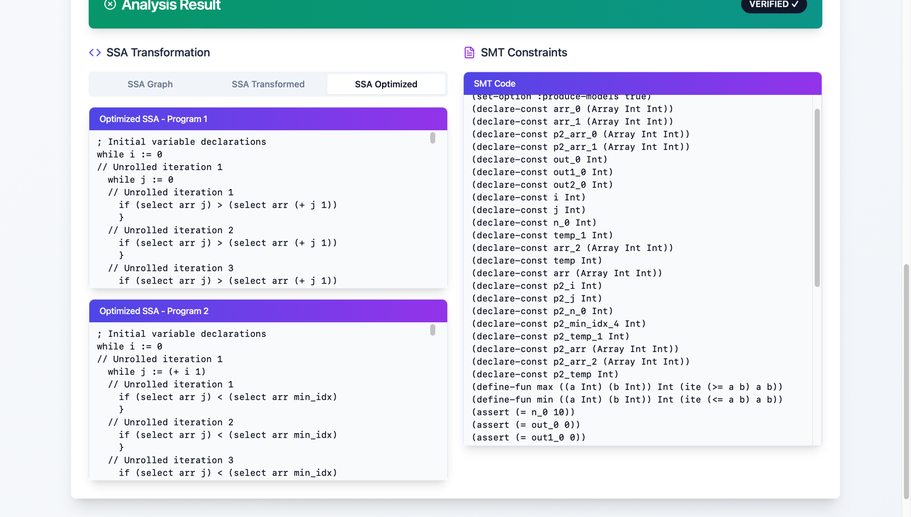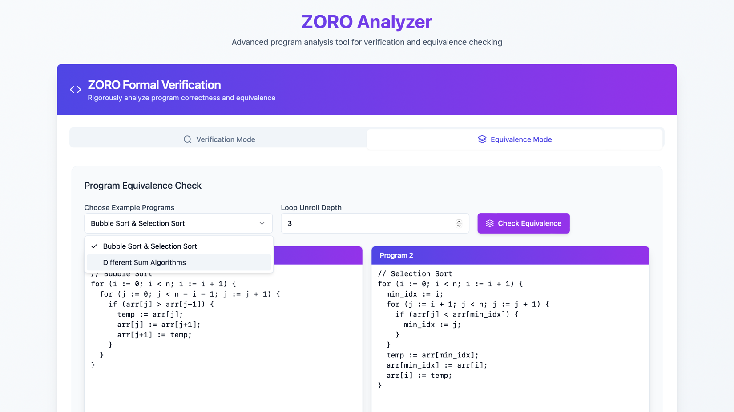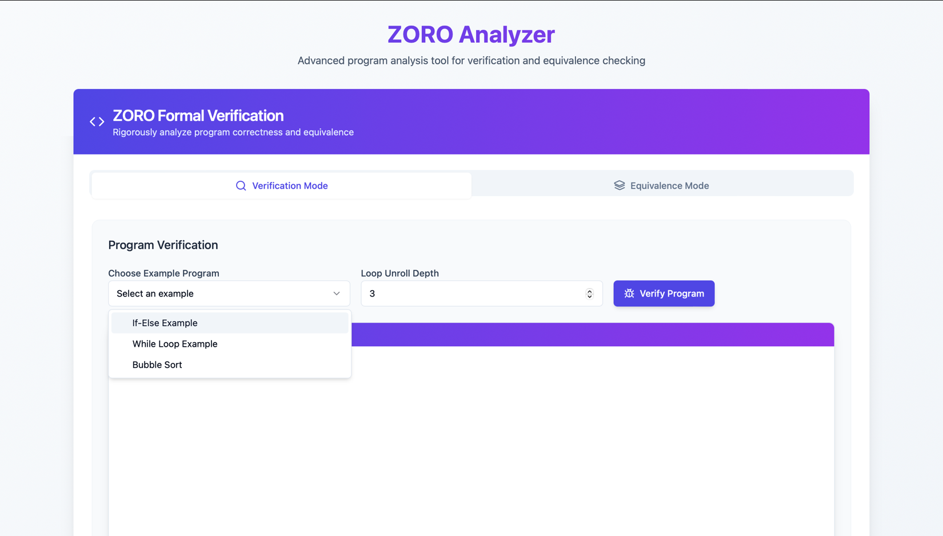

* **Input Panel**: Shows two text areas with sample programs, mode dropdown, and unroll depth input.
* **SSA Output**: Displays raw SSA (e.g., x_1 = 5; out_1 = (+ x_1 1)) and optimized SSA (e.g., out_1 = 6) side-by-side.
* **SMT Output**: Shows SMT formula with highlighted keywords like (assert), (declare-const).
* **CFG Output**: Visualizes nodes (statements) and edges (control flow) for a bubble sort program.
* **Results Panel**: Lists verified status, counterexamples (e.g., x_1 = -1, out_1 = -2), or example inputs (e.g., x_1 = 10, out_1 = 20).

**7. Sample Programs and Test Results**

**7.1 Verification Mode**

**Program 1: If-Else**

x := 10;

if (x < 5) {

y := x + 1;

} else {

y := x - 1;

}

assert(y > 0);

* **Result**: verified (unsat).
* **Example**: x_1 = 10, y_1 = 9 (satisfies y_1 > 0).
* **Counterexamples**: None (property holds).
* **Explanation**: For x_1 = 10, the else branch sets y_1 = 9, satisfying y_1 > 0. The negated assertion (not (> y_1 0)) is unsatisfiable.

**Program 2: Loop**

x := 0;

while (x < 4) {

x := x + 1;

}

assert(x == 4);

* **Result**: verified (unsat) with unroll depth 4.
* **Example**: x_4 = 4 (after 4 iterations).
* **Counterexamples**: None (assertion holds).
* **Explanation**: Unrolling 4 times sets x_4 = 4, satisfying the assertion. The negated assertion (not (= x_4 4)) is unsatisfiable.

**Program 3: Array Assignment**

arr[0] := 50;

out := arr[0];

assert(out >= 0);

* **Result**: verified (unsat).
* **Example**: arr_1 = (store arr_0 0 50), out_1 = 50 (satisfies out_1 >= 0).
* **Counterexamples**: None (property holds).
* **Explanation**: The output out_1 = 50 satisfies out_1 >= 0 and the property 0 <= out_1 <= 100.

**7.2 Equivalence Mode**

**Program Pair 1: Simple Arithmetic**

* **Program 1**:
* x := 5;
* out := x + 1;
* **Program 2**:
* y := 5;
* out := y + 1;
* **Result**: equivalent (unsat).
* **Example**: x_1 = 5, out1_1 = 6 and y_1 = 5, out2_1 = 6 (same output).
* **Counterexamples**: None (outputs are equal).
* **Explanation**: Both programs produce out_1 = 6, so (not (= out1_1 out2_1)) is unsatisfiable.

**Program Pair 2: Non-Equivalent**

* **Program 1**:
* x := 5;
* out := x * 2;
* **Program 2**:
* y := 5;
* out := y * 3;
* **Result**: not_equivalent (sat).
* **Counterexamples**:
  + x_1 = 5, out1_1 = 10 vs. y_1 = 5, out2_1 = 15.
  + x_1 = 0, out1_1 = 0 vs. y_1 = 0, out2_1 = 0 (same output, but first case shows difference).
* **Explanation**: The outputs differ (10 vs. 15), so (not (= out1_1 out2_1)) is satisfiable.

**8. Limitations**

* **Loop Unrolling Depth**: Limited by user-specified depth, which may miss behaviors beyond the unrolled iterations.
* **Array Assertions**: The forall construct is supported, but complex array properties (e.g., partial sortedness) require manual specification.
* **Parser Robustness**: Assumes well-formed input; malformed programs may cause parsing errors without detailed feedback.
* **Optimization Scope**: SSA optimizations are basic and may miss advanced opportunities (e.g., loop-invariant code motion).
* **Performance**: Large programs or high unroll depths can generate large SMT formulas, slowing down Z3.
* **Counterexample Generation**: Limited to two counterexamples due to Z3 model extraction constraints; more complex programs may need additional analysis.

**9. Potential Improvements**

* **Dynamic Unrolling**: Automatically adjust unroll depth based on program analysis (e.g., loop bounds).
* **Enhanced Parser**: Add error reporting for malformed inputs and support more complex expressions (e.g., function calls).
* **Advanced Optimizations**: Implement loop-invariant code motion and strength reduction for SSA.
* **Interactive CFG**: Allow users to click CFG nodes to view corresponding code or SMT constraints.
* **Incremental Solving**: Use Z3’s incremental mode to speed up analysis for large programs.
* **Extended Assertions**: Support more expressive array assertions (e.g., quantified formulas) natively in the GUI.

**10. Conclusion**

The developed tool successfully meets the objectives of parsing programs, converting to SSA, generating SMT constraints, and verifying correctness or equivalence using Z3. The GUI provides a clear visualization of all steps, including AST, SSA, SMT, CFGs, and results. Sample programs demonstrate the tool’s capabilities in both verification and equivalence modes, with examples and counterexamples clearly displayed. Despite some limitations, the tool is a robust foundation for formal program analysis, with clear paths for future enhancements.